Adapting a Saginaw Power Steering Pump
Nov. 01, 2004 By James Oxley
My 78 Bronco has power steering, but sometimes you wouldn't know it. After getting stuck more times than I like to remember, I decided to get the largest DOT legal tire I could find, 44" boggers (actually Firestone makes 46's :-)). After installing these tires, I had a lot of problems steering when stopped at idle. I decided to replace my PS pump with a ported saginaw pump (looks like canned ham) from AGR, but I could not find the exact bracket for a 351M/400 block. I found a bracket off a 78/79 Ford E-350 van with a 460 that looked real close. With some modification, it worked out great. I can now steer the boggers at idle with no problem. Mods to the bracket are listed below. I had to space it out from the block in all three mounting places. I used a spacer on the larger bolt. It is .840 in thick.

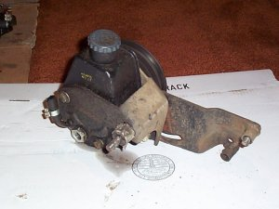

For the other two mounts I used thinwall tube (.665 OD/.475 ID) cut to .910 in length for upper mount and 1.014 in length for lower mount. Both of the left side mounts needed to be moved slightly. Using the upper edge of bracket as a reference and assuming all following dimensions are X-Y in that plane, upper mount needed to be moved .164 in towards the center of engine from original bolt hole in bracket. Lower mount needed to be moved .217 towards motor center of motor and .410 down.

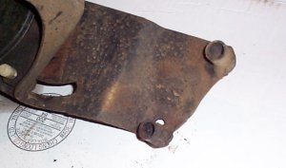

What I did was bolt up the bracket with the larger bolt near pump and have the tubing sit where it should be when it lines up with block mounting holes. I then tacked both of them in place and finished welding them up off the truck. Once they were welded in place, I redrilled holes using the tube as a guide. Lower hole had to have metal added (welded in) on the bracket to allow the tube to be welded on all sides. See how far the new holes are off from the old one's here.

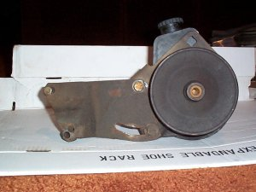

This is the closest bracket I could find. It was a decent amount of work, but it fits perfect and works great. I had the ease of fabbing it up with one of the broncs I bought that had no front end. It also fits perfect fits fine even with AC compressor still in place. I'm pretty sure I had to get a different length belt to allow pump to tilt slightly towards drivers side for perfect access to fill. Here is the bracket/pump installed. I ended up using a 17500 size belt. This is with the smaller water pump pulle that comes with the upgraded cooling. My original pully was larger and needed a 17510 belt.

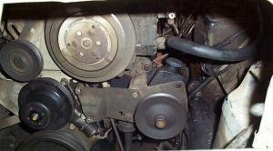

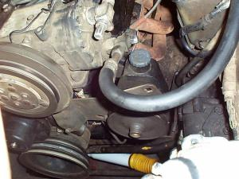

OX

