Your 2024 Silverado 2500 HD LT 4WD
Net Price
$57,400 †
Summary
Standard Vehicle Price
$52,200
Exterior
change
Summit White$0
Wheels
change
18" LT275/70R18E all-terrain, blackwall tires$200
18" 6-spoke machined aluminum wheels with Silver painted accents$300
Interior
change
40/20/40 split-bench front seat with under-seat storageStandard
Heated driver and front outboard passenger seats$0
10-way power driver seat with power lumbar$0
Heated steering wheel$0
Jet Black, Cloth seat trim$0
Packages
change
$2,135
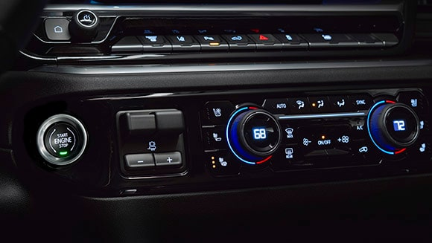
Heat Package
$400
Remote Start Package
$525
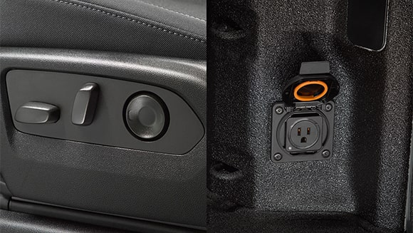
Convenience Package
$1,210
Options
change
$670

Allison® 10-speed automatic transmission
Standard
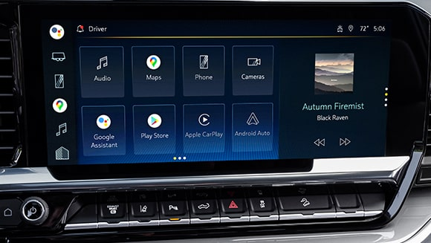
13.4" diagonal Chevrolet Infotainment 3 Premium System with Google built-in
Standard

6.6L V8 Gas engine
Standard
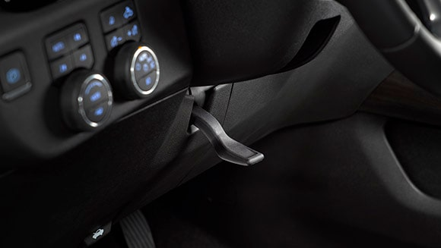
Manual tilt and telescoping steering column
Included in Package
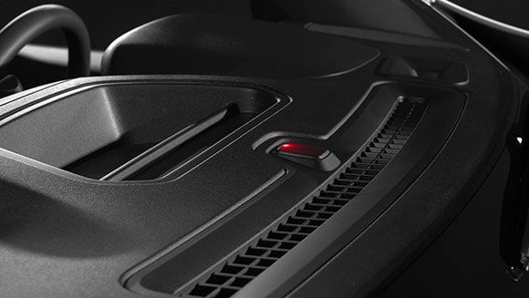
Theft-deterrent unauthorized entry system
Included in Package

Cargo bed LED lighting
Included in Package
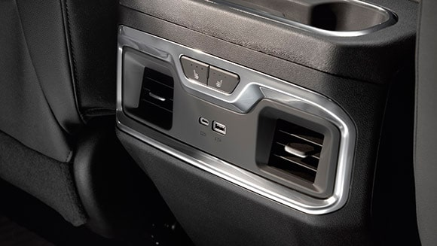
Charging-only USB ports, 2nd row
Included in Package
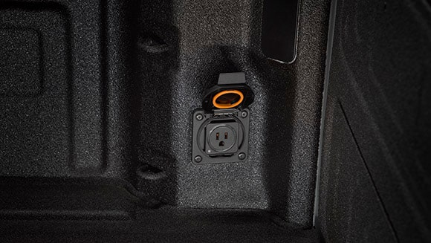
120-volt box-mounted power outlet
Included in Package

10,750 lbs. GVWR
$0
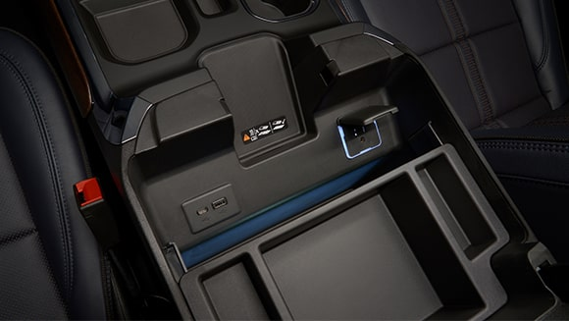
120-volt power outlet
Included in Package
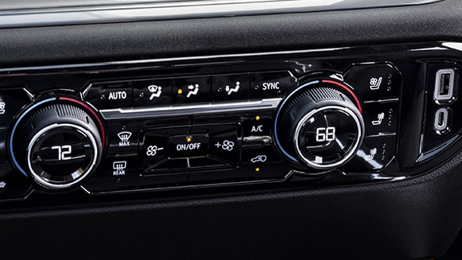
Dual-zone automatic climate control
Included in Package
Remote Start
Included in Package
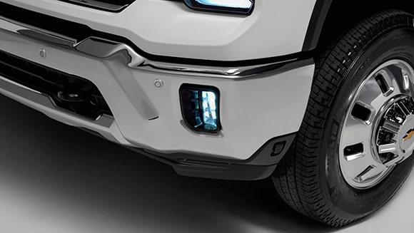
LED fog lamps
Included in Package
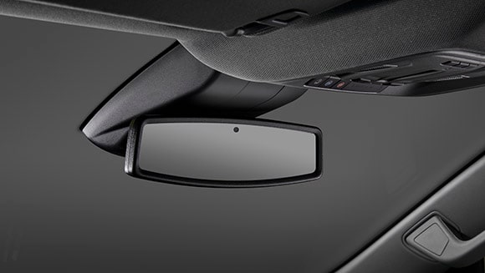
Inside rearview auto-dimming mirror
$0
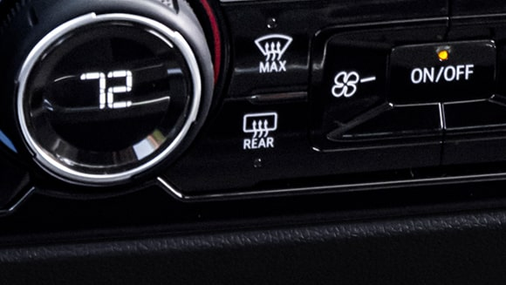
Rear window defogger
Included in Package

3.73 rear axle ratio
$0
Rear wheelhouse liners
$140
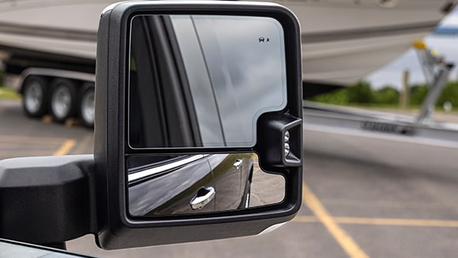
Black outside power-adjustable vertical trailering mirrors with power folding/manual extending auto-dimming driver upper glass
$530
Destination Freight Charge
$1,895
MSRP Total Vehicle Price
$57,400
Net Price
$57,400 †

