CUSTOM TUNING VEHICLE INFORMATION
www.efidynotuning.com rev.2020-10-28
__________________________________________________________
FORUM USERNAME [required]: OX
FULL NAME: Henry James Oxley
TELE#: Cell 7327400476
EMAIL: joxenburger@yahoo.com
POSTAL ADDRESS: 538 Challenger Wway, Jackson NJ 08527

VEHICLE YR/MAKE/MODEL: 1986 Mercury Capri 5.0
VEHICLE WEIGHT: 3280 lbs
__________________________________________________________
TUNE SERVICE TYPE [DYNO or ONLINE]: ONLINE
IS VEHICLE BEING DROPPED OFF FOR DYNO TUNE? [Y,N]: N
IF YES,
IS VEHICLE DRIVEABLE [Y,N]: Y
IS VEHICLE TAGGED & INSURED [Y,N]: N
LICENSE PLATE#:
__________________________________________________________
HOW DID YOU HEAR ABOUT EFIDYNOTUNING ?: Tuned Before
REFERRER: Self
__________________________________________________________
PRE-TUNE CHECKLIST VERIFIED [Y,N]:Y
If NO, Verify the Pre-Tune Checklist (linked above) Before Proceeding!
IS VEHICLE 100% READY TO BE TUNED [Y,N]? Y
LIST ALL DEFICIENCIES OR PENDING WORK BELOW:

NONE
__________________________________________________________
PCM CATCH CODE: A9L
(Ex: A9L, T4M0, AMZ1, WYN4, etc...)
PCM HARDWARE CODE:

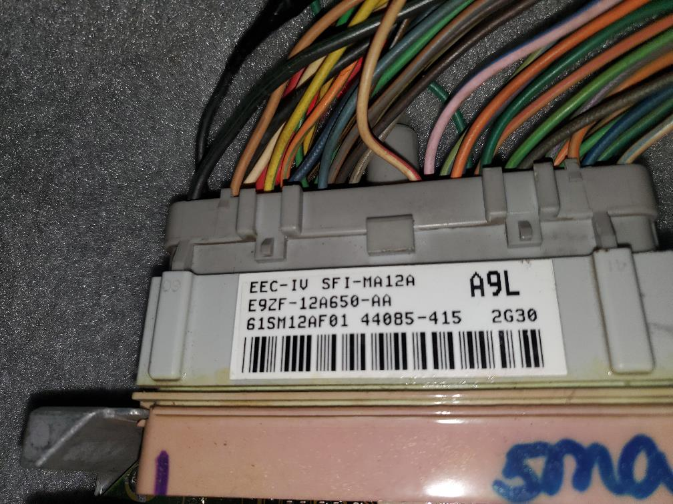

(Ex: MPC-15C, EFI-SD48B, SA112)
PCM CONTROLLED AUTO TRANS PRESENT? [Y/N]: N, Manual T-5

TUNING DEVICE (QH,Tweecer,Xcal,HPtuner,Kess,etc...): QuarterHorse
SCT DEVICE SERIAL # (SCT Xcal handheld):
TUNING SOFTWARE (TunerPro,Sykes,Caledit,SCT,HPT,etc): Binary Editor

PRIMARY VEHICLE USE (street,strip,weekend,show,daily,etc): Street
IS THIS YOUR PRIMARY VEHICLE [Y,N]: N
__________________________________________________________
TRANSMISSION MODEL NUMBER: 1989 Stock T-5 (V-8)
Gear Ratios: 1st: 3.35 2nd: 3rd: 4th: 5th: .67 6th:
REAR WHEEL TIRE SIZE: 275/50R15
TIRE REVS/MILE: 809
AXLE GEAR RATIO: 3.27
TQ CONVERTER MAKE:
TQ CONV STALL SPEED:
TRANS FLUID TYPE & SPEC:
VALVE BODY SPECS:
SHIFT KIT SPECS:
LIST ANY ADDITIONAL TRANSMISSION SPECS:
__________________________________________________________
INJECTOR SIZE: 47
INJECTOR BRAND: FMS
INJECTOR COLOR: ?
INJECTOR PART NUMBER:

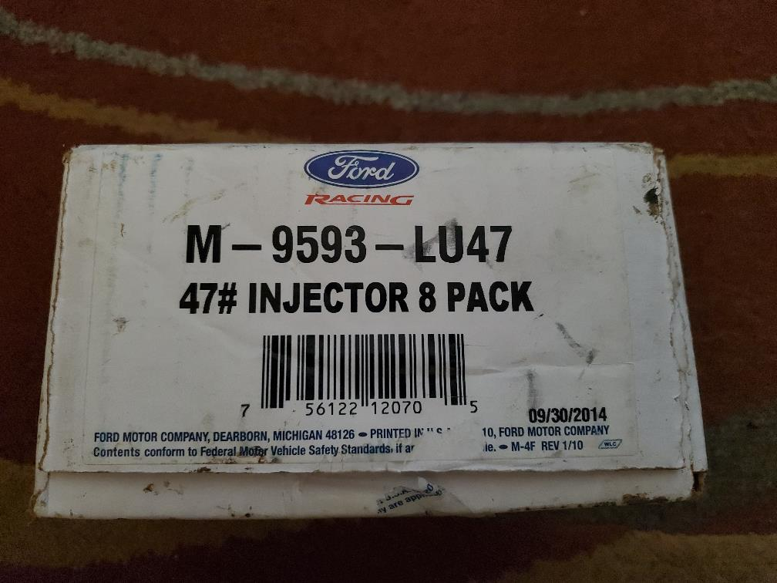

INJECTOR PURCHASE PRICE $: $200?
VENDOR PURCHASED FROM: SUMMIT
FUEL SYSTEM TYPE [STOCK, RETURN,RETURNLESS]:
ADJUSTABLE FUEL PRESSURE REGULATOR [Y,N]: Y
AFPR MAKE & MODEL#: KIRBIN 5005
BASE FUEL PRESSURE: 65 PSI (VAC HOSE DISCONNECTED AND PLUGGED)
FUEL PUMP QUANTITY & SIZE [LPH]: IN-TANK 110 LPH-FMS
IN-LINE SECONDARY PUMP-BOSCH GFP221 (RATED 121 LPH, SUPPORTED OVER 400 HP
WITH ORIGINAL CARTECH TURBO KIT @ 110 PSI. HAVE FUEL PRESSURE GUAGE, WILL KEEP AN EYE ON IT)
FUEL PUMP BRAND AND FPDM SPECS: SEE ABOVE
FUEL RAIL SPECS: STOCK
FUEL LINE SIZE: STOCK
LIST ANY ADDITIONAL FUEL SYSTEM DETAILS (expand if needed):

__________________________________________________________
FUEL TYPE OCTANE & GRADE: SUNOCO
FUEL RON/MON (for non-USA countries): 93
FUEL QUALITY [POOR,FAIR,AVG]: FRESH 5/27/2023 (TANK DRAINED COMPLETELY PRIOR to FILL)

METH INJECTION NOZZLE GPH:
METH ACTIVATION TYPE OR SET PSI:

N2O Wet/Dry Shot:
N2O SHOT / NOZZLE SIZE:
N2O FUEL JET SIZE:
N2O Bottle Warmer Present [Y,N]:
N2O WOT Safety Switch [Y,N]:
LIST ANY ADDITIONAL N2O DETAILS:

__________________________________________________________
ENGINE BLOCK SPECS: STOCK 86 5.0 HO
DECK MIL'd ?: (if so how much mils shaved?): NO
COMPRESSION RATIO:
CUBIC INCH DISPLACEMENT/LITERS:
CYLINDER HEAD BRAND: TW
CYL HEAD PART/MODEL# :
CYL HEAD RUNNER SIZE CC:
CYL HEAD CHAMBER SIZE: 170
CYL HEADS MIL'D? : NO, NO HEAD WORK
(if so, how many mils have been shaved?):
APPROX. HOW MANY MILES ON ENGINE?: 88K
PISTON SPECS (include GAP if known): STOCK 86 FORGED
I AM ORIGINAL ONWER, ORIGINAL X-HATCHING STILL THERE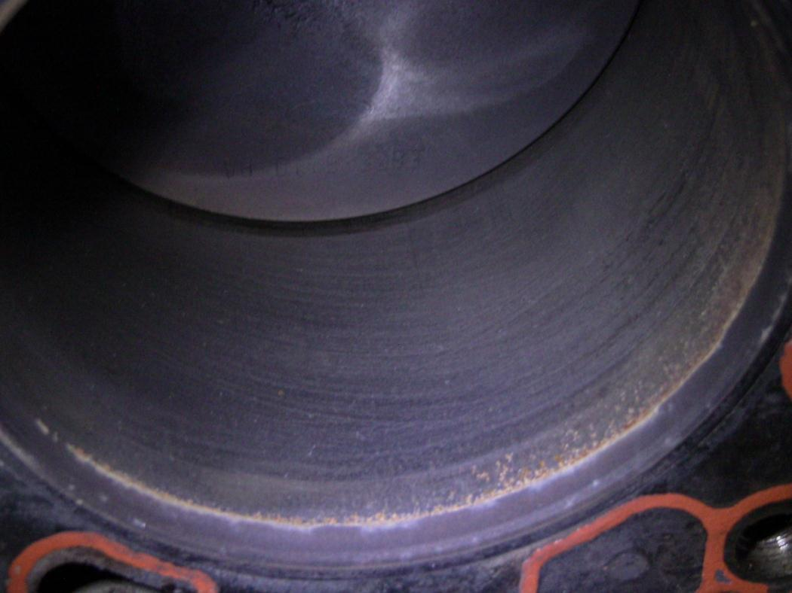

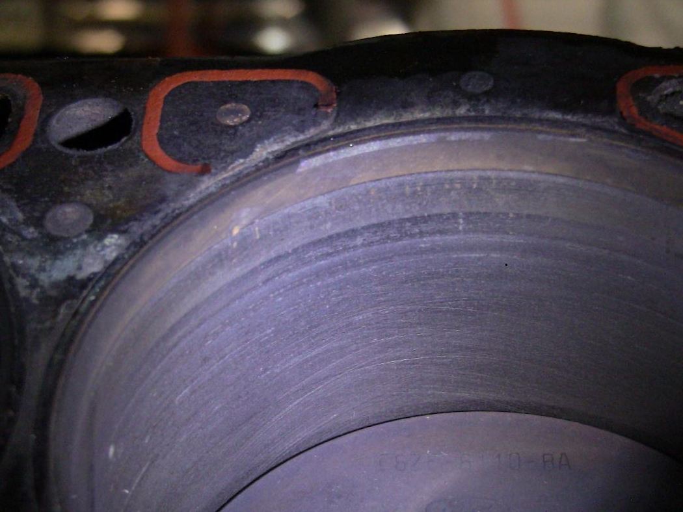

ROD SPECS: (include if ARP bolts): STOCK RODS, ARP BOLTS
Fully Forged Rotating Assembly ?: NO NEW ROD/MAINBEARINGS, CRANK POLISHED
BILLET OIL PUMP GEARS [Y,N]: STOCK NEW FORD PUMP
LIST ANY ADDITIONAL ENGINE BOTTOM END SPECS:

__________________________________________________________
POWER ADDER TYPE [Turbo,SC,n2o]:
TURBO/SC MAKE/MODEL#:
TURBO SIZE & AR / PULLEY SIZE:
LOWER PULLEY SIZE:
#s BOOST MAXIMUM:
BOOST CONTROLLER PRESENT [Y,N]:
BOV/BYPASS LOCATED BEFORE OR AFTER MAF?:
LIST ANY ADDITIONAL POWER ADDER DETAILS:

__________________________________________________________
EXHAUST HEADER TYPE [LONGTUBES/MID/SHORTY]:
EXHAUST CROSSOVER TYPE [X,H,Y-PIPE]:
EXHAUST PIPE SIZE, SPECS, & COMMENTS:

WIDEBAND MODEL AND PART #:
WIDEBAND WIRED IN TO PCM EGR INPUT? [Y,N]:
***IF YOU HAVE YOUR WIDEBAND TRANSFER, LIST HERE OR ATTACH BELOW

__________________________________________________________
ELECTRIC FANS PRESENT [Y,N]:
HIGH AND LOW WIRED TO PCM:
COOLANT THERMOSTAT TEMP:
AIR CHARGE TEMP SENSOR LOCATION:
__________________________________________________________
MASS AIR FLOW SENSOR TYPE:
MAF TUBE/HOUSING SIZE:
MAF/INLET PIPING SIZE:
IS MAF CALIBRATED FOR AN INJECTOR SIZE [Y/N]:
IF YES,
MAF CALIBRATION SIZE:
MAF CALIBRATION VEHICLE:
MAF CALIBRATION CURVE [Ex: GT,COBRA,SC,etc...]:
MAF BLOW-THROUGH or DRAW-THROUGH:
***IF MAF FLOW SHEET IS AVAILABLE, LIST HERE OR ATTACH BELOW***
LIST ANY ADDITIONAL MAF NOTES/COMMENTS:

__________________________________________________________
THROTTLE BODY MAKE & PART NUMBER:
THROTTLE BODY SIZE:
INTAKE MANIFOLD SPECS:
LIST ANY ADDITIONAL INTAKE SPECS:

__________________________________________________________
CAM BRAND AND PART NUMBER:
Intake Lift: Duration: Centerline:
Exhaust Lift: Duration: Centerline:
Rocker Ratio:
PREFERRED IDLE RPM:
DESIRED REV-LIMITER RPM:
***IF CAM CARD IS AVAILABLE, ATTACH FILE AT BOTTOM***
LIST ANY ADDITIONAL CAMSHAFT COMMENTS:

__________________________________________________________
IGNITION COIL SPECS:
IGNITION COIL TYPE [CoP,COIL PACKS,1 COIL]:
DISTRIBUTOR BRAND & PART NUMBER:
SPARK PLUG BRAND, PART #, and GAP:
SPARK PLUG WIRES, SIZE, BRAND & AGE:
IGNITION BOX TYPE & AGE:
***BASE IGNITION TIMING MUST BE 10 BTDC ON DISTRIBUTORS***
IS BASE TIMING AT 10 dBTDC [Y,N]?:
LIST ANY ADDITIONAL IGNITION DETAILS:

__________________________________________________________
QUICK CHECK LIST:
HOW MUCH OIL DOES ENGINE BURN? :
AGE OF FUEL FILTER :
AGE OF SPARK PLUGS:
AGE OF CAP AND ROTOR:
AGE OF PLUG WIRES:
AGE OF AIR FILTER:
AGE OF O2 SENSORS:
O2 LOCATED BEFORE OR AFTER TURBO:
WIDEBAND LOCATED BEFORE OR AFTER TURBO:
EXHAUST SEALED W/ NO LEAKS? [Y,N]:
WHAT IS BASE TIMING SET TO (dBTDC):
FIRING ORDER VERIFIED [Y,N]:
LIST ANY ADDITIONAL VEHICLE DETAILS/COMMENTS/NOTES BELOW:
(EXPAND THIS SECTION IF NEEDED)

